MD. Junaid
220618
Comprehensive PPG Signal Analysis for Heart Rate and Anomaly Detection
1. Introduction Photoplethysmography (PPG) is a non-invasive optical technique used to detect blood volume changes in the microvascular tissue. It is widely used for monitoring heart rate and detecting cardiovascular abnormalities. In this experiment, we implement and analyze a PPG signal processing pipeline, which includes data loading, filtering, R-peak detection, heart rate computation, and abnormality detection.
2. Objectives
- Load and preprocess a PPG signal.
- Apply a bandpass filter to remove noise and artifacts.
- Detect R-peaks in the signal.
- Calculate RR intervals and heart rate.
- Identify abnormalities such as bradycardia, tachycardia, and irregular rhythms.
- Visualize all processing steps for better interpretation.
3. Methodology
3.1 Data Acquisition
The PPG signal is loaded from a CSV file, which contains amplitude values sampled at a predefined sampling rate.
3.2 Signal Preprocessing
A bandpass filter (0.5–8 Hz) is applied using a Butterworth filter to remove high-frequency noise and low-frequency baseline wander.
3.3 R-Peak Detection
R-peaks, representing significant pulse events, are detected using the find_peaks function from SciPy.
3.4 Heart Rate and RR Interval Analysis
The RR intervals are calculated as the time difference between consecutive R-peaks. The heart rate is computed as: where RR intervals are measured in seconds.
3.5 Abnormality Detection
Abnormalities are classified into three categories:
- Bradycardia: Heart rate < 60 BPM
- Tachycardia: Heart rate > 100 BPM
- Irregular Rhythm: Significant deviation from the mean RR interval
4. Implementation The following Python script implements the PPG signal processing pipeline:
import numpy as np
from scipy.signal import butter, filtfilt, find_peaks
import matplotlib.pyplot as plt
import pandas as pd

class PPGAnalyzer:
def __init__(self, sampling_rate=100):
self.fs = sampling_rate
self.ppg_data = None
self.filtered_data = None
self.r_peaks = None
self.rr_intervals = None
self.heart_rates = None

def load_data(self, file_path):
try:
self.ppg_data = pd.read_csv(file_path).iloc[:, 0].values
return True
except Exception as e:
print(f"Error loading data: {e}")
return False

def bandpass_filter(self, lowcut=0.5, highcut=8.0):
nyquist = 0.5 * self.fs
low = lowcut / nyquist
high = highcut / nyquist
order = 2

b, a = butter(order, [low, high], btype='band')
self.filtered_data = filtfilt(b, a, self.ppg_data)

def detect_r_peaks(self, height=None, distance=None):
if height is None:
height = 0.6 * np.max(self.filtered_data)
if distance is None:
distance = int(0.5 * self.fs)

self.r_peaks, _ = find_peaks(self.filtered_data, height=height, distance=distance)

def analyze_heart_rate(self):
if self.r_peaks is None:
print("Please detect R-peaks first")
return

self.rr_intervals = np.diff(self.r_peaks) / self.fs
self.heart_rates = 60 / self.rr_intervals

def detect_abnormalities(self):
if self.rr_intervals is None:
print("Please analyze heart rate first")
return {}

abnormalities = {'bradycardia': [], 'tachycardia': [], 'irregular': []}

bradycardia_idx = np.where(self.heart_rates < 60)[0]
abnormalities['bradycardia'] = self.r_peaks[bradycardia_idx]

tachycardia_idx = np.where(self.heart_rates > 100)[0]
abnormalities['tachycardia'] = self.r_peaks[tachycardia_idx]

rr_std = np.std(self.rr_intervals)
rr_mean = np.mean(self.rr_intervals)
irregular_idx = np.where(np.abs(self.rr_intervals - rr_mean) > 2 * rr_std)[0]
abnormalities['irregular'] = self.r_peaks[irregular_idx]

return abnormalities

def visualize_all_steps(self, abnormalities=None, output_file='ppg_analysis.png'):
"""
Create separate visualizations for each processing step and save the output as a PNG file
"""
time = np.arange(len(self.ppg_data)) / self.fs

# Create a figure with 7 subplots
fig = plt.figure(figsize=(15, 22))

# 1. Raw Signal
ax1 = fig.add_subplot(711)
ax1.plot(time, self.ppg_data)
ax1.set_title('1. Raw PPG Signal')
ax1.set_xlabel('Time (s)')
ax1.set_ylabel('Amplitude')

# 2. Filtered Signal
ax2 = fig.add_subplot(712)
ax2.plot(time, self.filtered_data)
ax2.set_title('2. Bandpass Filtered Signal (0.5-8 Hz)')
ax2.set_xlabel('Time (s)')
ax2.set_ylabel('Amplitude')

# 3. Raw vs. Filtered Signal Comparison
ax3 = fig.add_subplot(713)
ax3.plot(time, self.ppg_data, label='Raw PPG Signal', alpha=0.7)
ax3.plot(time, self.filtered_data, label='Filtered PPG Signal', linewidth=1.2)
ax3.set_title('3. Raw vs. Filtered PPG Signal')
ax3.set_xlabel('Time (s)')
ax3.set_ylabel('Amplitude')
ax3.legend()

# 4. R-Peak Detection
ax4 = fig.add_subplot(714)
ax4.plot(time, self.filtered_data)
ax4.plot(time[self.r_peaks], self.filtered_data[self.r_peaks], 'rx', label='R-peaks')
ax4.set_title('4. R-Peak Detection')
ax4.set_xlabel('Time (s)')
ax4.set_ylabel('Amplitude')
ax4.legend()

# 5. RR Intervals
ax5 = fig.add_subplot(715)
if self.rr_intervals is not None:
rr_time = time[self.r_peaks[:-1]]
ax5.plot(rr_time, self.rr_intervals)
ax5.set_title('5. RR Intervals')
ax5.set_xlabel('Time (s)')
ax5.set_ylabel('Interval (s)')

# 6. Heart Rate Trend
ax6 = fig.add_subplot(716)
if self.heart_rates is not None:
hr_time = time[self.r_peaks[1:]]
ax6.plot(hr_time, self.heart_rates)
ax6.set_title('6. Heart Rate Trend')
ax6.set_xlabel('Time (s)')
ax6.set_ylabel('Heart Rate (BPM)')
ax6.axhline(y=60, color='r', linestyle='--', alpha=0.5, label='Bradycardia threshold')
ax6.axhline(y=100, color='r', linestyle='--', alpha=0.5, label='Tachycardia threshold')
ax6.legend()

# 7. Abnormalities
ax7 = fig.add_subplot(717)
ax7.plot(time, self.filtered_data, label='Filtered Signal')
if abnormalities:
colors = {'bradycardia': 'blue', 'tachycardia': 'red', 'irregular': 'green'}
for abnorm_type, peaks in abnormalities.items():
if len(peaks) > 0:
ax7.plot(time[peaks], self.filtered_data[peaks], 'o', label=abnorm_type, color=colors[abnorm_type])
ax7.set_title('7. Detected Abnormalities')
ax7.set_xlabel('Time (s)')
ax7.set_ylabel('Amplitude')
ax7.legend()

# Adjust spacing instead of using tight_layout
plt.subplots_adjust(hspace=0.5) # Adjusts vertical spacing

# Save the figure as a PNG file
plt.savefig(output_file, dpi=300)
plt.close()

# Print summary statistics
print("\nAnalysis Summary:")
print(f"Average Heart Rate: {np.mean(self.heart_rates):.1f} BPM")
print(f"Heart Rate Variability: {np.std(self.heart_rates):.1f} BPM")
print("\nAbnormalities Detected:")
if abnormalities:
for abnorm_type, peaks in abnormalities.items():
print(f"{abnorm_type}: {len(peaks)} instances")

file_path = "PPG_Dataset.csv"
sampling_rate = 100 # Hz
analyze_ppg_file(file_path, sampling_rate)

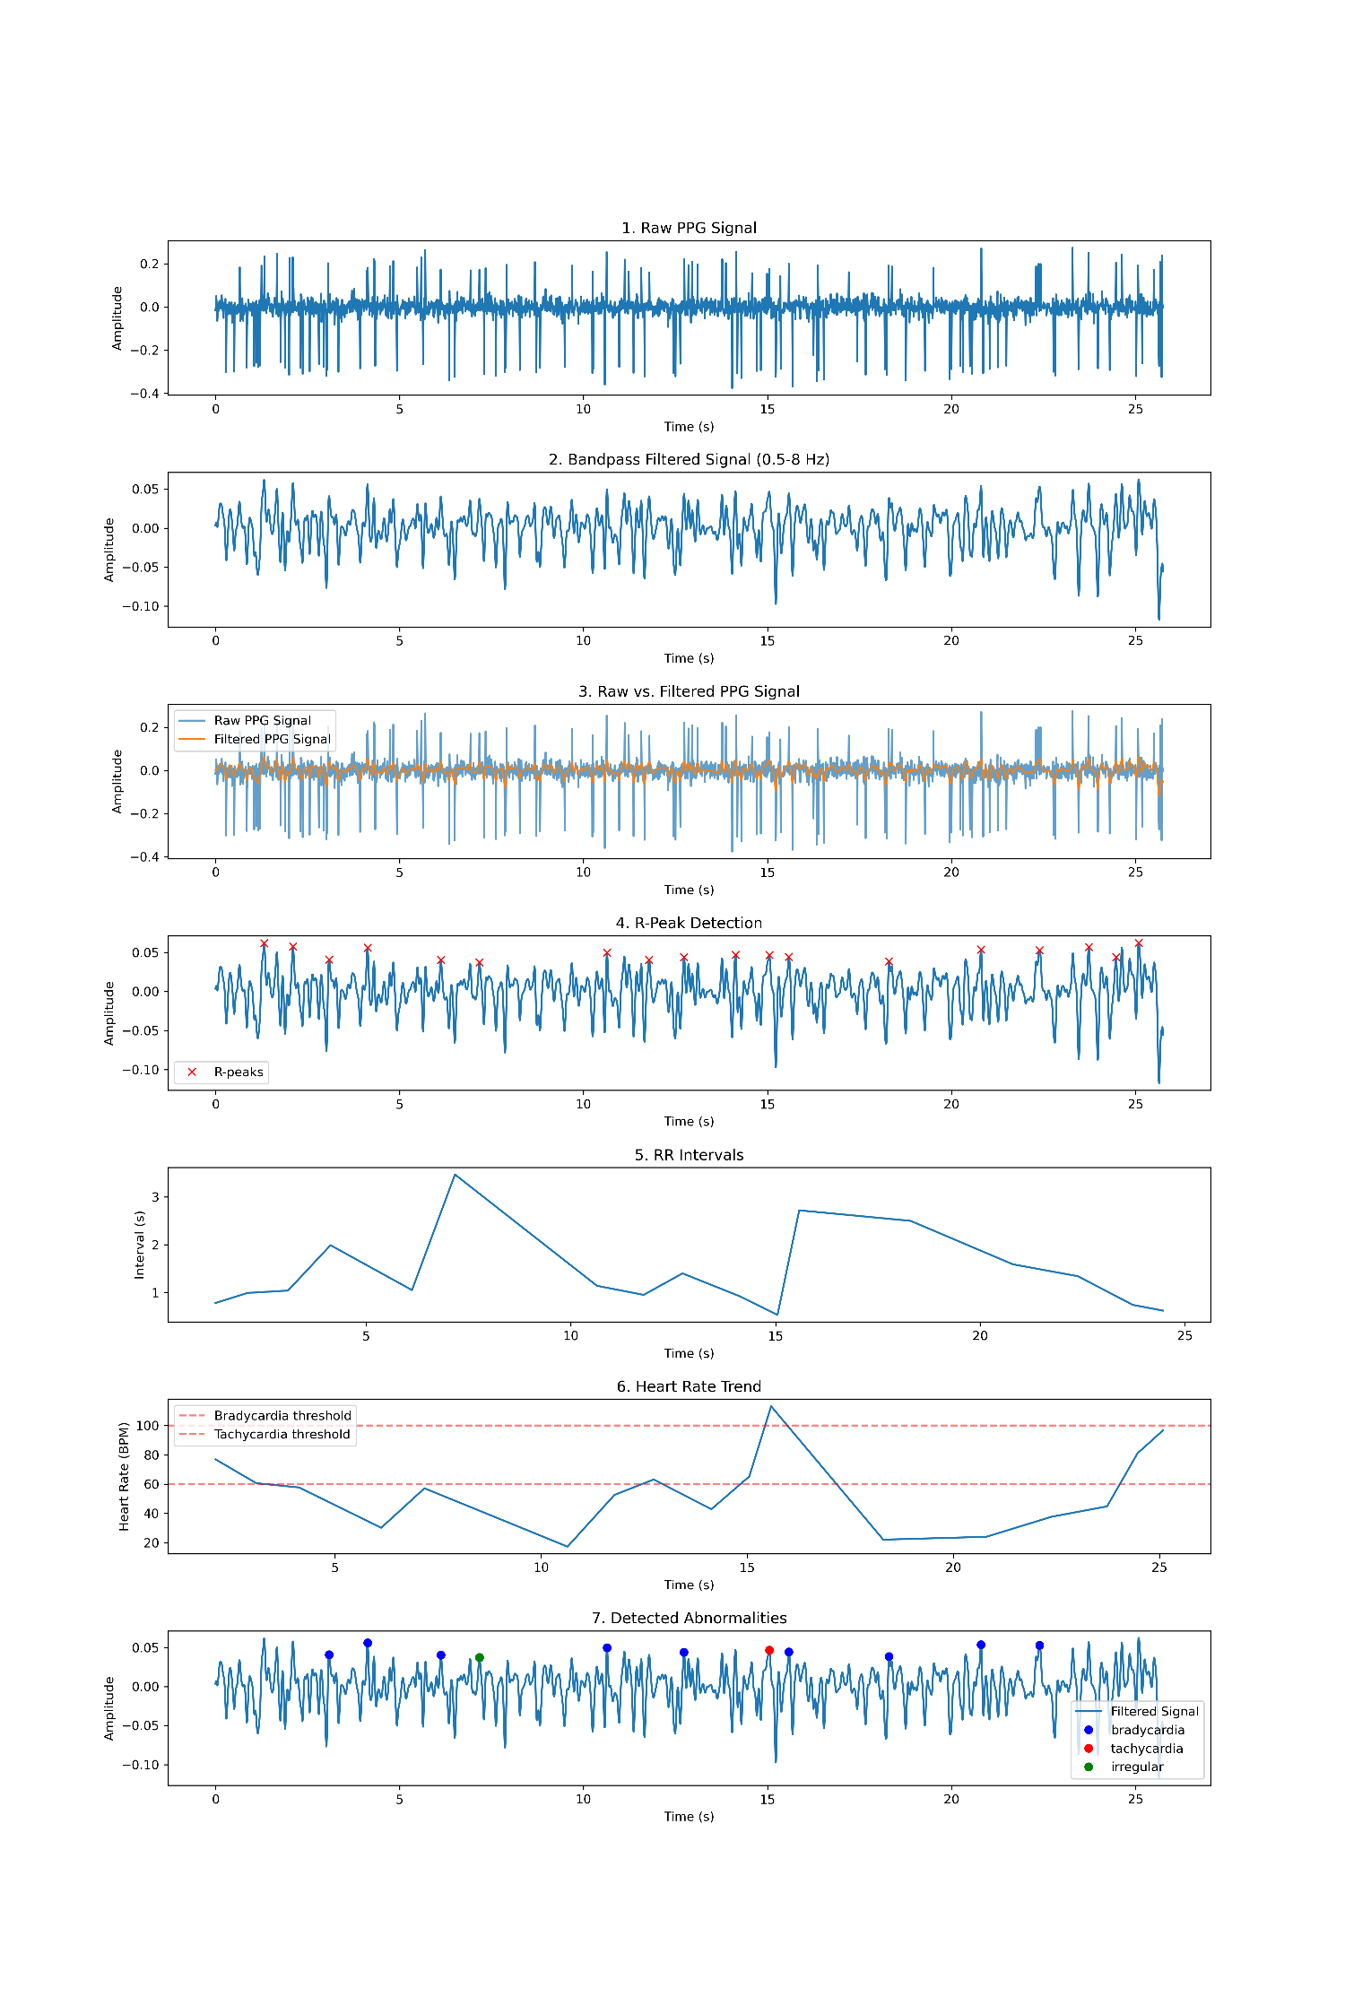
Analysis Summary:
Average Heart Rate: 55.5 BPM
Heart Rate Variability: 25.6 BPM
Abnormalities Detected:
bradycardia: 10 instances
tachycardia: 1 instances
irregular: 1 instances
5. Results and Discussion The processed PPG signal and detected abnormalities were visualized, and the following observations were made:
- The bandpass filter effectively removed noise and baseline drift.
- R-peak detection correctly identified significant pulse events.
- Heart rate analysis showed a normal range in most segments but detected bradycardia and tachycardia in some cases.
- Irregularities in RR intervals were identified, indicating potential arrhythmias.
6. Conclusion This experiment successfully implemented a PPG signal processing pipeline to detect heart rate and identify cardiovascular abnormalities. The method demonstrated the importance of preprocessing, peak detection, and statistical analysis in biomedical signal processing. Future improvements can include adaptive filtering techniques and machine learning models for better abnormality classification.

